TURKEY TAIL
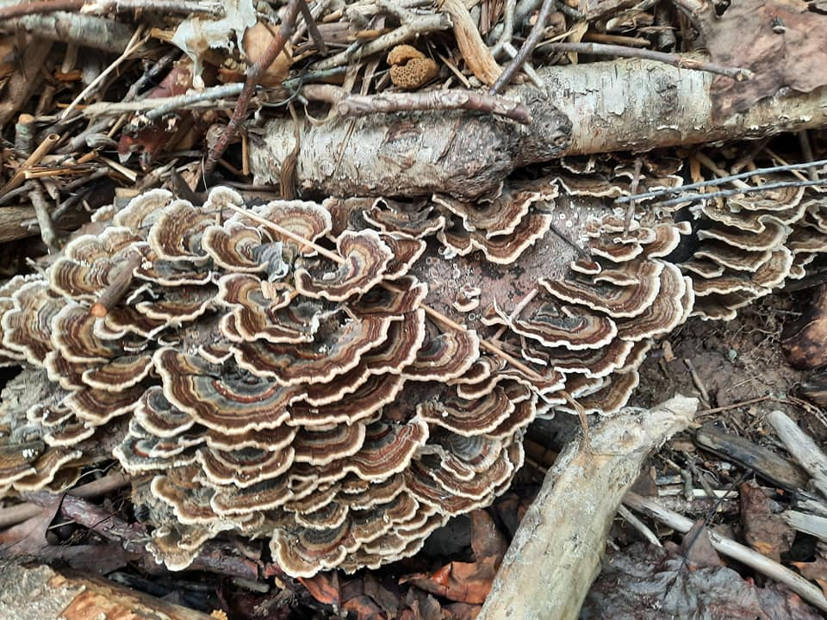
Trametes versicolor
Actions: tonic, adaptogen, immunomodulator, anti-tumor, anti-viral, anti-bacterial, antioxidant
Energy is neutral
Turkey tail uses.
- Increase levels of cancer fighting cells.
- Support the immune system
- Improves digestion by providing prebiotic support
- Contains polysaccharopeptide and polysaccharide-k which inhibit cancer cells’ growth
- Manage inflammation
- Sooth aches
- Prevent and treat cold and flu
- Helps aid cancer patients during chemo
- Promotes relaxation, reduces stress and anxiety
- Natural source of energy
Recommended dose Adults 1.5mL, 2 times per day. Increase dose if fighting cancer or illness to 4 times a day.

There are no contradictions with medications and no serious side effects reported.

Turkey tail is one of the most studied medicinal mushrooms and is being used in many countries along side chemo to fight cancer. It offers deep immunity support and increases gut health.

